Ministry of Education of Moldova

Technical University of Moldova

Faculty "Computers, Informatics and Microelectronics"

Anglophone Department

Report

Web development

A efectuat:

st. gr. TI-154 Baltag Maxim

A veificat:

lect. asist. Victor Gojin

Chişinău -2017
I have chosen Django CMS and used Sublime for editor.
i started from a very easy tutorial which helped me finishing the work

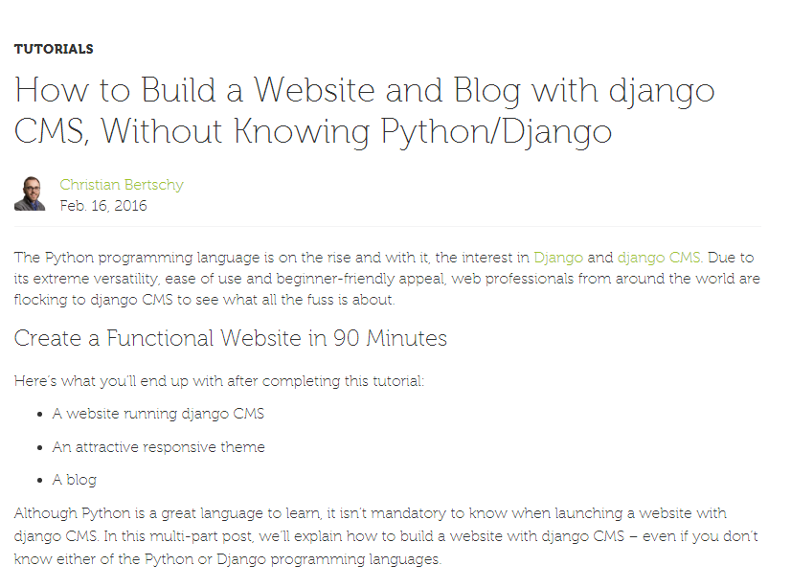

Then i took a clean blog theme from here
http://startbootstrap.com/template-overviews/clean-blog/

Then i get my free acount on Aldryn
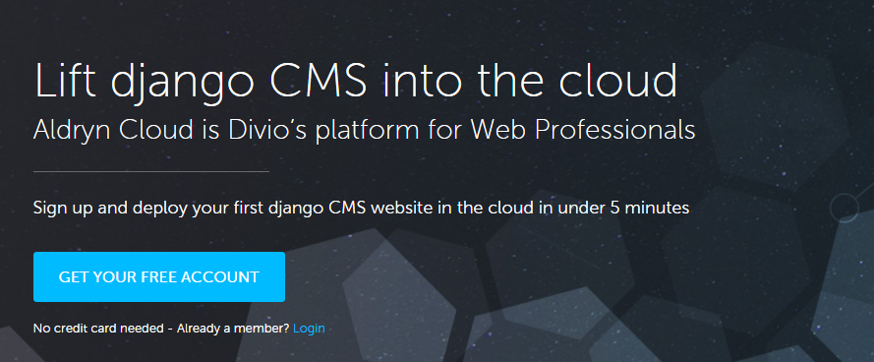

And i started my new project

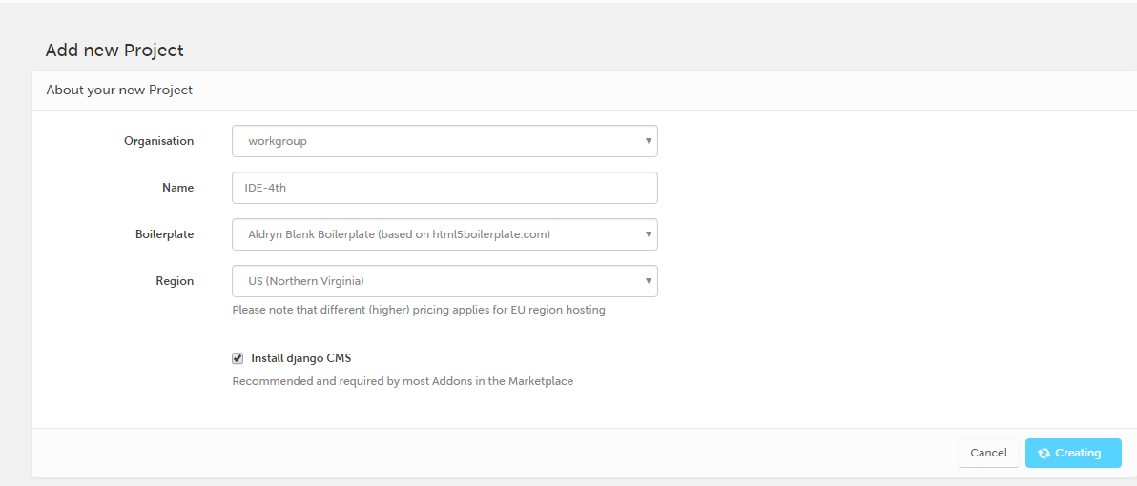
We want to install two additional addons :
- Aldryn Bootstrap 3
- Aldryn News & Blog

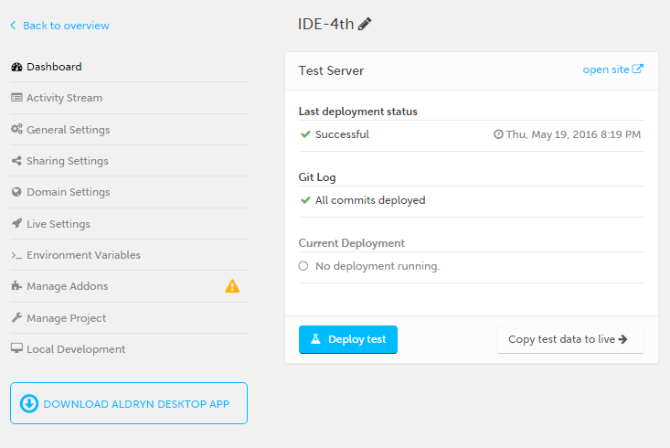
After this i deployed test on my site. This deployed my website to a test environment on the Aldryn Cloud for free.
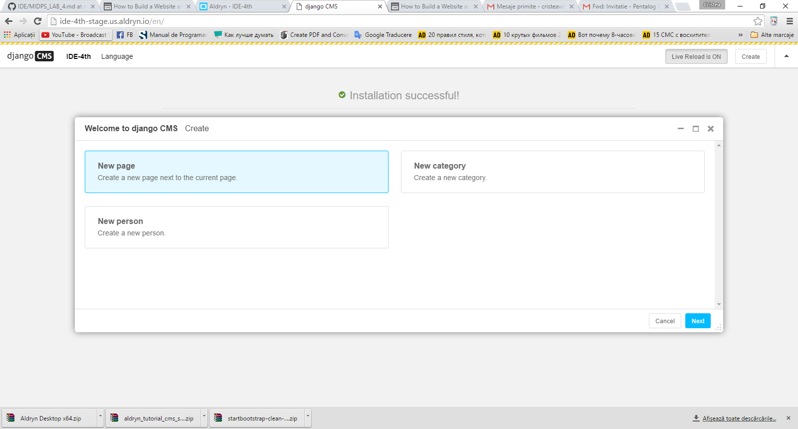
My result till this very moment.

Installing desktop app
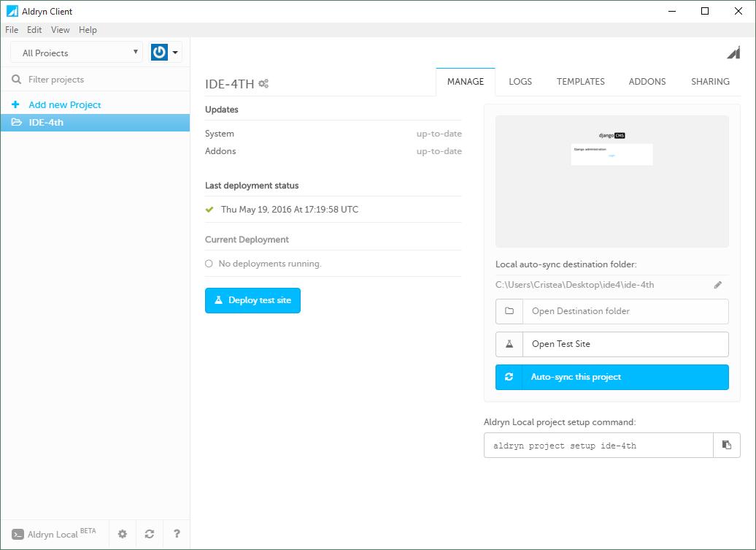

Creating 3 static pages: Home,Blog,Random

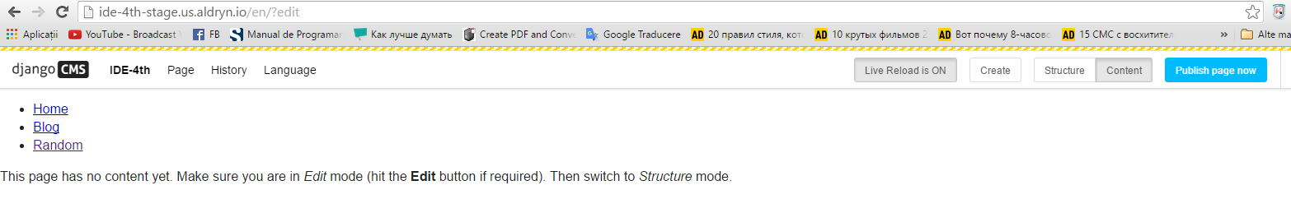
After this i published them.

Then from my clean blog theme i copied into my project’s “static” folder
- css
- fonts
- img
- js
Since we want to incorporate the previously downloaded theme, i copied the about.html file from the downloaded theme folder into my project’s “templates” folder.
Then, deleted the base.html file and renamed the about.html to base.html.
After changing in the base.html my website look like this
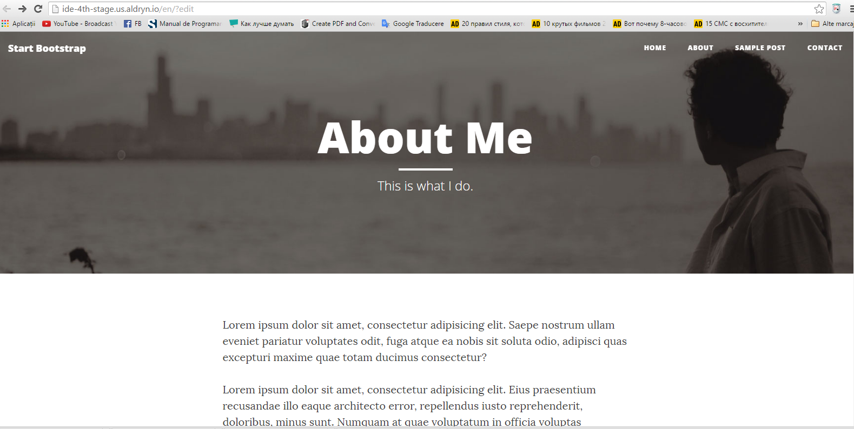
Everything was done and should be modified with Sublime Text 3.
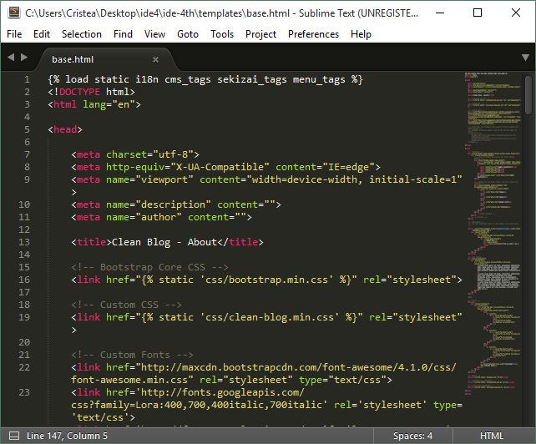

Steps performed after:

Changing the Content Placeholder

Creating Different Header Images for EachPage

Defining Default Content

Adding Content
Because we have no content or plugins added yet, our home page is pretty empty.
Before we add our first text plugin, we need to get familiar with the different view modes the CMS offers:
Editing View
This is the mode i’ll use for adding content and changing my structure.

Adding first Generic Text addon and writing there something.

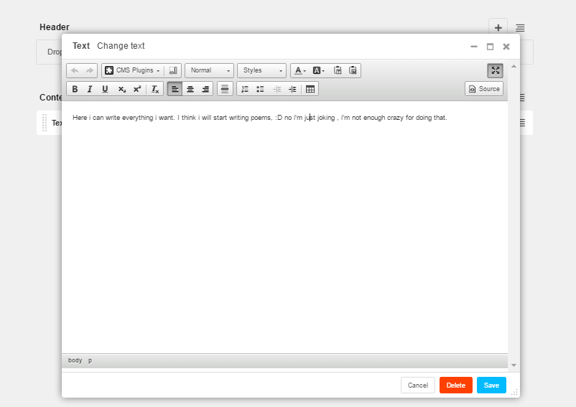

Advanced: Rebuilding the HTML Structure with Nested Plugins
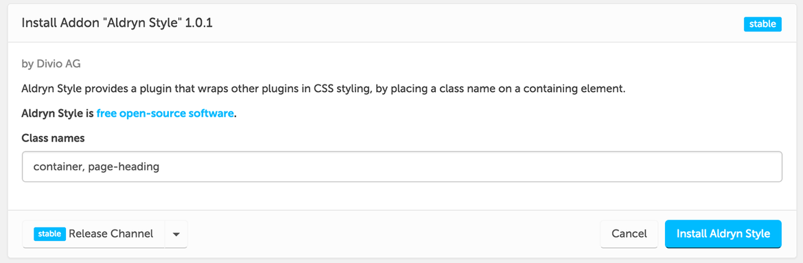

We start building this structure by adding plugins into the placeholder “Header.”
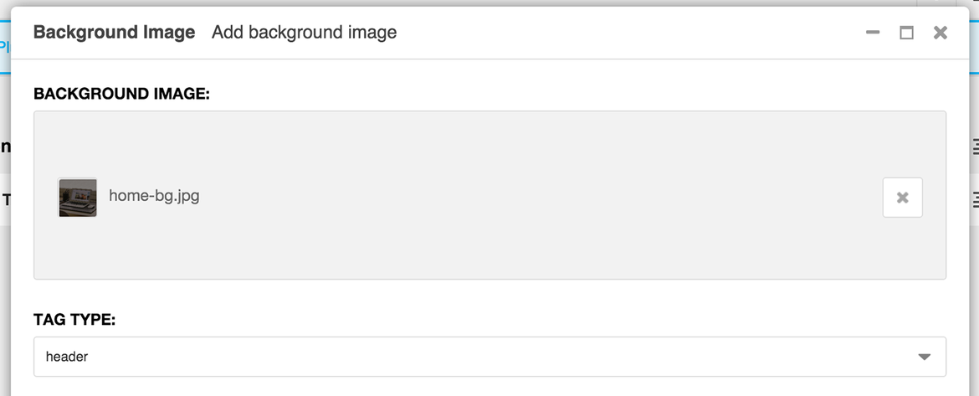

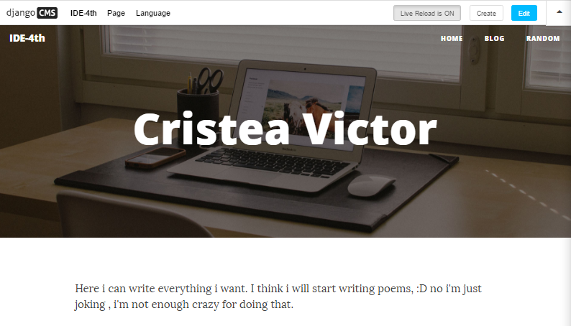

Getting to Know Aldryn News & Blog
Adapting My Blog-Templates.Pagination
It will look quite plain because you only have one page, but after you’ve added more than five blog posts, the pagination will look like this:

Now let’s adapt the template for the actual blog post, which is referred to as “detail_view.”

Adding Content
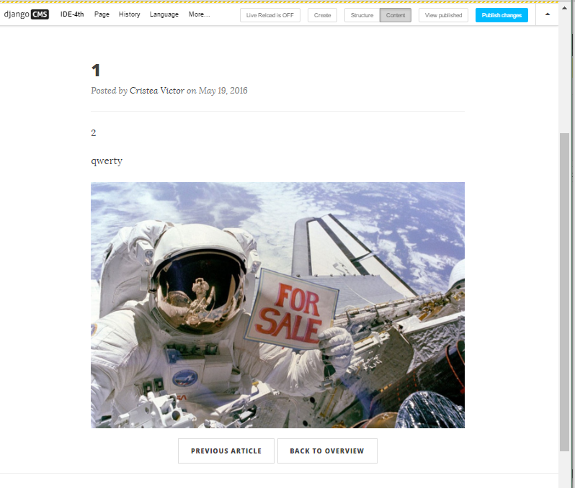

Fine-tuning the Aldryn News & Blog Addon
Then i added some code and it does the following:
If there is an image, our site will display it with a size of 1200x400 pixels. Otherwise, it will use the default “img/post-bg.jpg” from the template, since the “Featured Image” setting is optional.



Implementing a Contact Form

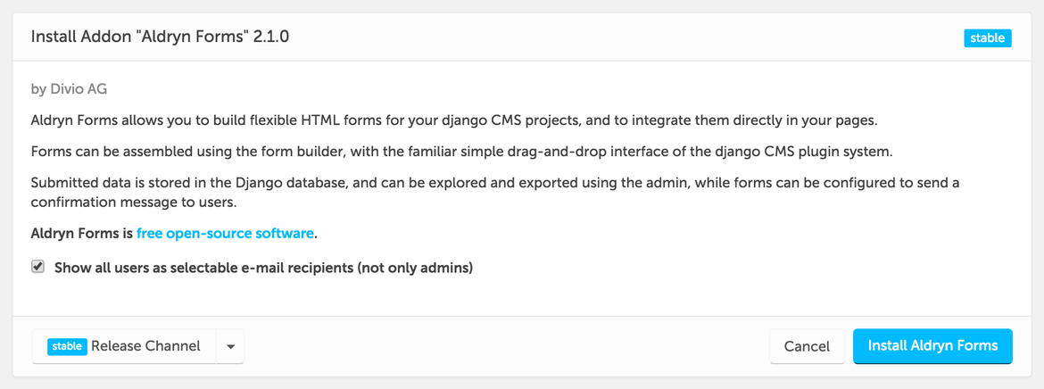

While my site is deploying, i head back to my Clean Blog files and open “contact.html” in Sublime to make some modifications

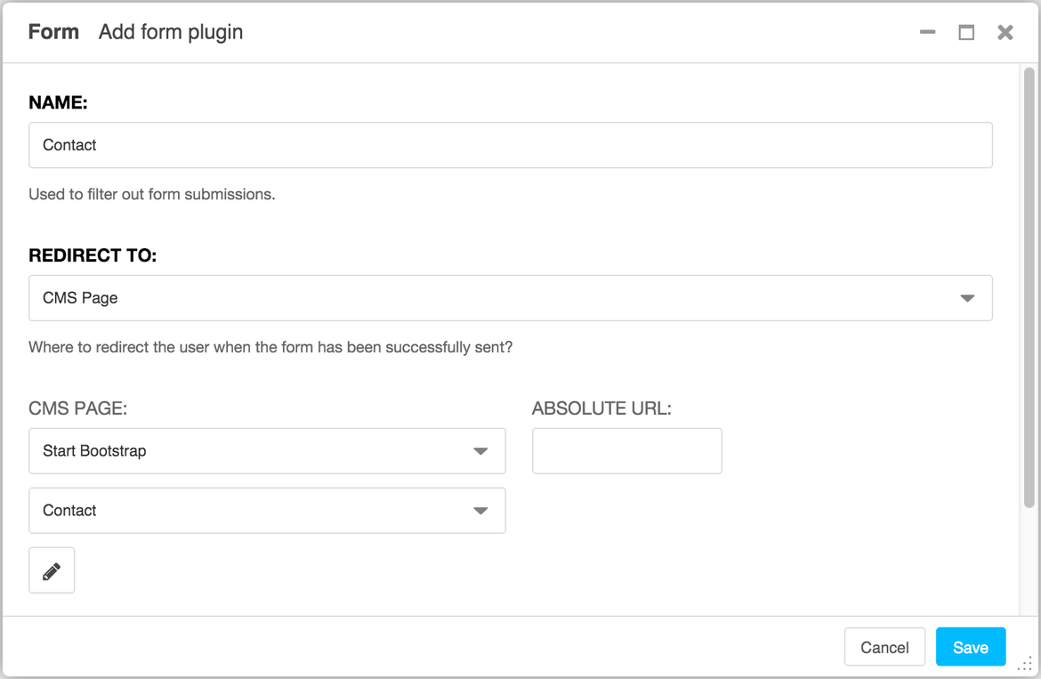

Next, we need to add the form elements. Our theme has four fields defined and a submission button:
- Name
- Email Address
- Phone Number
- Message
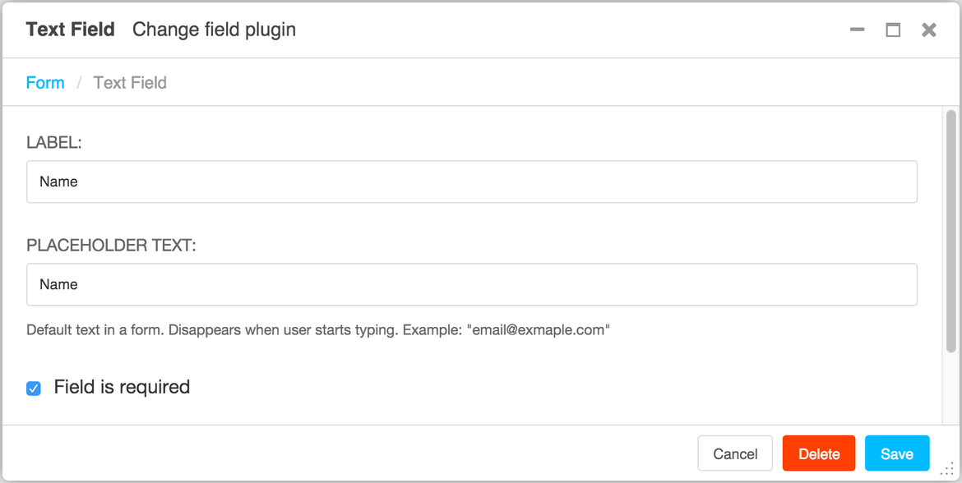
- Send

Setup Aldryn Locally

Now that we have everything setup on our computer, let’s get our project to run locally. I selected my project and copy the command indicated in the “Aldryn Client project setup command.”
After some modifications project is now set up locally. Inside my Terminal,i typed in “cd ,” hit tab on my keyboard and then hit enter. This selected my Projects folder. Next, let’s run our project locally by typing:

Login to Your Local Project
If my local server is located at http://192.168.99.100:8000/, the URL would become http://192.168.99.100:8000/?edit. Clicked on “Create user” and created a new account for myself Then lick on “Login as...” and selected the newly created user from the drop-down, before confirming with “Sign in.”

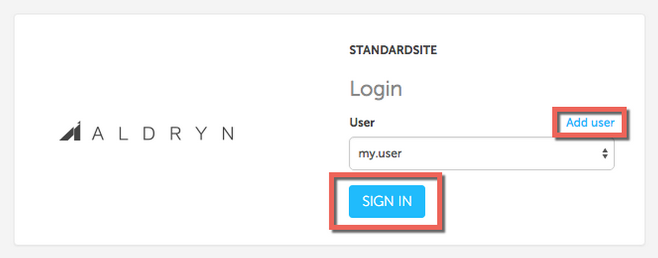

Creating Your First Django Application
In this part, we’ll cover how i can add a new Django app to my existing project, which will extend the basic CMS “Page” with two additional “Extra settings”:
- Subtitle - for displaying a subtitle underneath our header.
- Background Image - for displaying a custom background image in our header.

The following files are automatically created for you:
__init__.py | This (empty) file is used to mark directories as Python package directories.
admin.py | Contains instructions for the Django admin site on how this application’s models are handled.
migrations/ | Database migrations for the application.
models.py | Description of data in the database, represented as Python code.
tests.py | Application-specific test cases.
views.py | View functions for your application.

Setup the application
Django Models
Django models are descriptions of how data is stored in the database as code. Tr
Django models are descriptions of how data is stored in the database as code. Traditionally, you would create the database structure through SQL commands or a UI tool such as phpMyAdmin. Django does this through your code. Let’s have a look at an example: cture through SQL commands or a UI tool such as phpMyAdmin. Django does this through your code. Let’s have a look at an example:
class Person(models.Model):
first_name = models.CharField(max_length=50)
last_name = models.CharField(max_length=50)
birthday = models.DateField()
This code tells your database to create a tabl
This code tells your database to create a table “Person” with three fields named “first_name,” “last_name” and “birthday.” Each of the columns can have certain properties. “First_name,” for example, is a “Character Field” that allows you to store up to 50 characters. There are many more options available . “Person” with three fields named “first_name,” “last_name” and “birthday.” Each of the columns can have certain properties. “First_name,” for example, is a “Character Field” that allows you to store up to 50 characters. There are many m
Tip: if you closed the Browser and need the URL again, simply use the command “aldryn project open.”
Click on “Page” and you will see a new entry called “Extra settings” – the one we added just a few moments ago. Click on the menu entry and add a subtitle and example image of your choice.
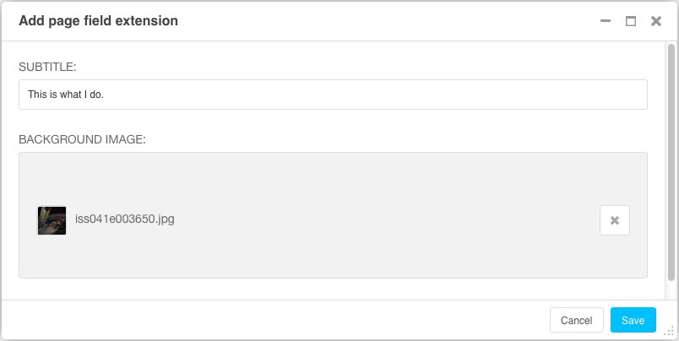
Before we can see the result of our new app, we have to adapt the Django templates for it.
If you want to change the default page title, head to “Page” followed by “Page settings” and fill in “Page title” with your desired title. This information will be different from what is displayed in the menu or page tree and serves specifically to set our heading title. “Publish changes” to wrap things up. 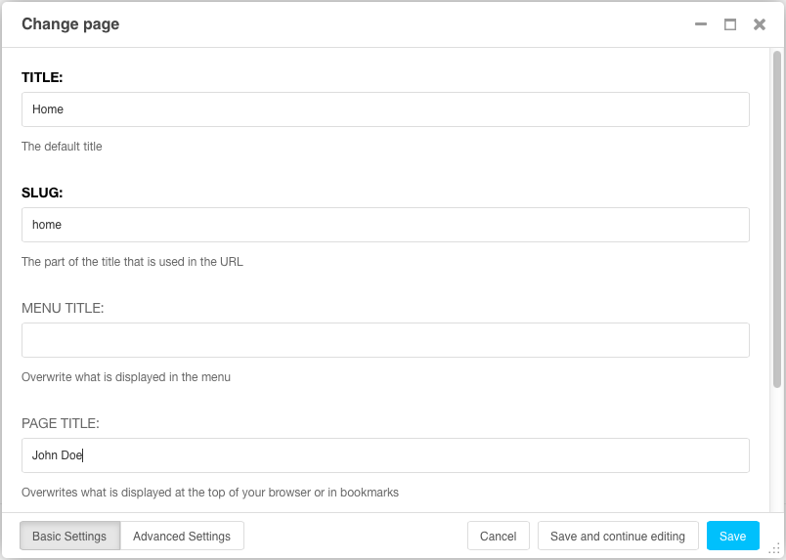
After saving all changes, reload the page again and you should see now the background image and subtitle you defined before:
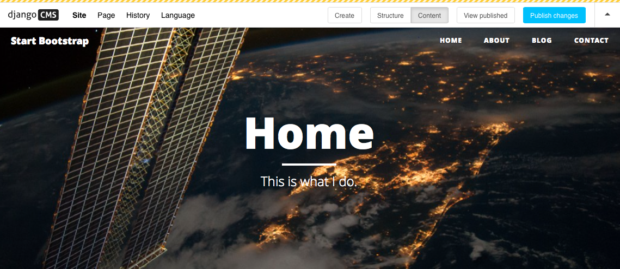

Conclusions:

It was an interesting laboratory work because i have to find a lot of new stuff and get documented with a lot of tutorials.
The tasks of this laboratory work weren't so tough if I could be using .NET or even JAVA, but unfortunately I cannot use them. So I choose Python with Django CMS.
From the start it seemed easy, I created a new project, then in order to create necesarry files and configuration I used a clean blog theme moved files from there to my project. After that I had some problems with routing, I only managed to route the template files, but with static files like css and images I had problems.
This laboratory was interesting because i have done some beautiful for a newbie site i like it and hope it won’t crash after first sesions. The tutorial lied about those 90 minute i have used more than 7 ours to fix everything because it crashed one time and i couldnt restore everything back and had to start it all over , it was a pain.
And all of this is because I haven’t done this before . Such type of laboratory works are good , because they are made for making students to learn how to learn fast and with a higher quality.
Here you can see the tutorial which i used as example to make a project
https://www.django-cms.org/en/blog/2016/02/16/build-a-website-without-knowing-python-django-part-one/

